Opioid settlement planning Worksheet

Overview

Background
In 2021, a $26 billion nationwide settlement was reached to resolve all Opioids litigation brought by states and local political subdivisions against the three largest pharmaceutical distributors: McKesson, Cardinal Health and AmerisourceBergen (“Distributors”), and manufacturer Janssen Pharmaceuticals, Inc. and its parent company Johnson & Johnson (collectively, “J&J”). In 2022, additional settlements with pharmacies and manufacturers were announced, including CVS, Walmart, Allergan and Teva. Fifty percent (50%) of the settlement amounts will be sent directly to county and local governments. Payments for all six settlements will be received separately. Eighty-five percent (85%) of funds must be used for opioid remediation, with seventy percent (70%) being used for future opioid remediation. Exhibit E of the settlements provides a non-exhaustive list of expenditures that qualify as being paid for Opioid Remediation. Opioid Remediation is defined as,
Care, treatment, and other programs and expenditures (including reimbursement for past such programs or expenditures except where this Agreement restricts the use of funds solely to future Opioid Remediation) designed to
(1) address the misuse and abuse of opioid products,
(2) treat or mitigate opioid use or related disorders, or
(3) mitigate other alleged effects of, including on those injured as a result of, the opioid epidemic.
Exhibit E provides a non-exhaustive list of allowable uses.
This planning worksheet was developed as a supplemental tool to the Michigan Opioid Settlement Funds Toolkit: A Guide for Local Spending.

Point of Contact
Who is the point of contact leading opioid settlement related planning?
County: _______________________________________________________________________________________________________
Name and title: _______________________________________________________________________________________________
Department: __________________________________________________________________________________________________
Email and phone: _____________________________________________________________________________________________

Vision
What is the vision associated with the use of opioid settlement funds in your county? ________________________________________________________________________________________________________________________________________________________________________________________________________________________________________________________________________________________________________________________________________________________________________________________________________________________________________________________________________________________________________________________________________________________________________________

Guiding principles
What are the guiding principles associated with the planning and use of opioid settlement funds? Will your county adopt the John Hopkins Bloomberg School of Public Health Principles?
- Spend money to save lives
- Use evidence to guide spending
- Invest in youth prevention
- Focus on racial equity
- Develop a fair and transparent process for deciding where to spend the funding
________________________________________________________________________________________________________________________________________________________________________________________________________________________________________________________________________________________________________________________________________________________________________________________________________________________________________________________________________________________________________________________________________________________________________________

PLANNING PROCESS STEPS

Identify Where to start
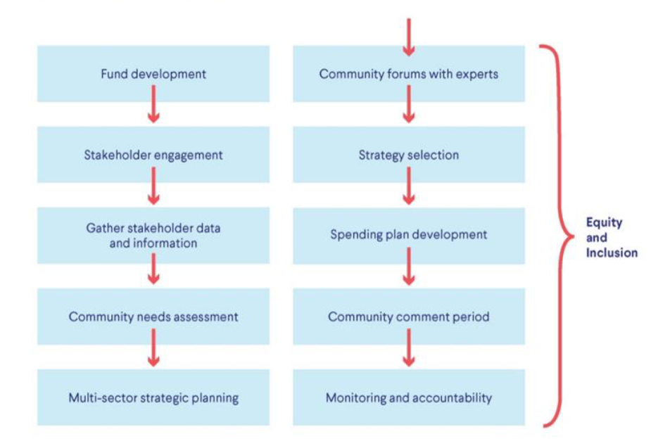

Fund MANAGEMENT
Has your county developed a separate and restricted fund for opioid settlement dollars? The associated fund number should be 284. ________________________________________________________________________________________________________________________________________________________________________________________________________________________________
Has your county determined an average annual amount to allocate? Annual funding amounts paid by settling parties will differ. Settlements are designed for a maximum number of payments, as opposed to annual payments. ________________________________________________________________________________________________________________________________________________________________________________________________________________________________
Has your county executed all settlement agreements?
________________________________________________________________________________________________________________
________________________________________________________________________________________________________________
Has your county registered in the settlement payment portal with BrownGreer, Directing Administrator of the National Opioid Settlements, to receive payments?
________________________________________________________________________________________________________________
________________________________________________________________________________________________________________

Stakeholder engagement
Which stakeholders has your county already engaged? Suggested groups include:
- Individuals with lived experience with substance use disorder and people who use drugs
- Communities that are and have been historically marginalized
- Family and friends of those with lived experience and people who use drugs
- Government officials and policymakers
- Prevention groups
- Harm reduction providers
- Treatment providers
- Mental health providers
- Recovery support providers
- Healthcare communities
- Medical examiners and coroners
- Local businesses
- Youth and family service providers
- Criminal-legal system and public safety
- Non-profits and community groups
- Schools and universities
- Faith-based communities
- Others engaged: _____________________________________________________________________________________
Which stakeholders are missing from the conversation?
________________________________________________________________________________________________________________________________________________________________________________________________________________________________
Are persons with lived experience with substance use disorder involved? If not, what are the barriers? ________________________________________________________________________________________________________________________________________________________________________________________________________________________________
Are persons who use drugs involved? If not, what are the barriers? ________________________________________________________________________________________________________________________________________________________________________________________________________________________________
Has a neutral convener been identified? ________________________________________________________________________________________________________________________________________________________________________________________________________________________________
How will your county engage stakeholders? ________________________________________________________________________________________________________________________________________________________________________________________________________________________________________________________________________________________________________________________________________________________________________________________________________________________________________________________________
Which parts of the process are stakeholders engaged in?
- Understanding local data
- Understanding local needs
- Development of strategic or action plan
- Determination of strategies/activities to fund
- Development of spending plan
- Development of public-facing reporting tools (dashboards, reports, etc.)
- Other: ________________________________________________________________________________________________

Equity and inclusion
Are underserved populations a part of the planning process?
________________________________________________________________________________________________________________________________________________________________________________________________________________________________________________________________________________________________________________________________________________________________________________________________________________________________________________________________
How can your county incorporate underserved populations and those with experience with substance use?
________________________________________________________________________________________________________________________________________________________________________________________________________________________________________________________________________________________________________________________________________________________________________________________________________________________________________________________________
Best practices for inclusion of those with lived experience with substance use and persons who use drugs in planning/steering committee meetings.
- Invite several individuals and/or invite a peer-based group to select representatives.
- Invite people who formerly used drugs, in addition to people who actively use drugs.
- Listen to and integrate feedback.
- Provide information about what the meeting is about, what their role will be, who else will be present (law enforcement, behavioral health providers, faith-based community, etc.) and how participants can contribute.
- Guarantee and protect confidentiality.
- Provide stipends, as all other participants will most likely be paid for their time.

Gather stakeholder information and Data
What information has your county gathered (past needs assessments, landscape analyses, strategic plans, action plans, etc.)? ________________________________________________________________________________________________________________________________________________________________________________________________________________________________________________________________________________________________________________________________________________________________________________________________________________________________________________________________
What information does your county still need? ________________________________________________________________________________________________________________________________________________________________________________________________________________________________________________________________________________________________________________________________________________________________________________________________________________________________________________________________
Which data partners are involved in the process (health department, medical examiner office, law enforcement, corrections, emergency medical services, hospitals, etc.)? ________________________________________________________________________________________________________________________________________________________________________________________________________________________________________________________________________________________________________________________________________________________________________________________________________________________________________________________________
Is there capacity to gather and analyze data? ________________________________________________________________________________________________________________________________________________________________________________________________________________________________
How will you make the information transparent including outcomes?
________________________________________________________________________________________________________________________________________________________________________________________________________________________________
How will year 5 look as compared to year 1? How will your program evolve as needed and what data will be used to measure successful outcomes?
________________________________________________________________________________________________________________________________________________________________________________________________________________________________
What additional support is needed? ________________________________________________________________________________________________________________________________________________________________________________________________________________________________

Community needs assessment
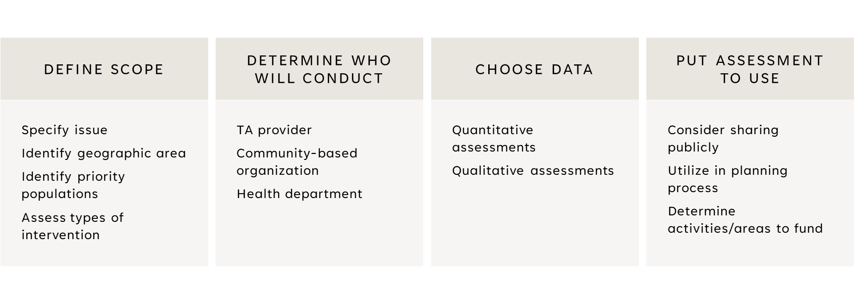Has a needs assessment already been conducted? ________________________________________________________________________________________________________________________________________________________________________________________________________________________________
Does your county have the capacity to complete a needs assessment? If not, free technical assistance to conduct a community needs assessment is available. ________________________________________________________________________________________________________________________________________________________________________________________________________________________________________________________________________________________________________________________________________________________________________________________________________________________________________________________________
Who will facilitate a county needs assessment (department, organization, etc.)? ________________________________________________________________________________________________________________________________________________________________________________________________________________________________

Multi-sector strategic planning
Utilize existing infrastructure created and information gathered in the needs assessment phase:
- Neutral convener
- Stakeholders engaged
- Information on existing efforts
What other sources of funding can be braided with settlement funds? ________________________________________________________________________________________________________________________________________________________________________________________________________________________________________________________________________________________________________________________________________________________________________________________________________________________________________________________________

Community Forums with experts
At which points in the planning process do you expect to hear from experts? ________________________________________________________________________________________________________________________________________________________________________________________________________________________________________________________________________________________________________________________________________________________________________________________________________________________________________________________________
Is there specific technical assistance that your county needs? MAC can provide or connect you with subject matter experts. ________________________________________________________________________________________________________________________________________________________________________________________________________________________________________________________________________________________________________________________________________________________________________________________________________________________________________________________________
Would hearing from experts help your residents understand decisions made around where dollars are being spent? ________________________________________________________________________________________________________________________________________________________________________________________________________________________________________________________________________________________________________________________________________________________________________________________________________________________________________________________________

Strategy Selection
How will your county ensure all who wish to submit proposals for funding are able to do so? ________________________________________________________________________________________________________________________________________________________________________________________________________________________________________________________________________________________________________________________________________________________________________________________________________________________________________________________________
Or will only pre-screened and pre-qualified organizations/service providers be invited to submit funding and program proposals?
________________________________________________________________________________________________________________________________________________________________________________________________________________________________
Which strategies will be prioritized and why? ________________________________________________________________________________________________________________________________________________________________________________________________________________________________________________________________________________________________________________________________________________________________________________________________________________________________________________________________
Do the strategies selected assist those most impacted by the drug overdose crisis (underserved populations, persons with lived experience with substance use disorder, persons that use drugs, families, etc.)? ________________________________________________________________________________________________________________________________________________________________________________________________________________________________
Is there a long-term strategy to ensure funds are used in each part of the continuum of care (prevention, harm reduction, treatment, recovery)? ________________________________________________________________________________________________________________________________________________________________________________________________________________________________________________________________________________________________________________________________________________________________________________________________________________________________________________________________

Spending plan development
Do you need to spend more in year 1 that includes one-time funding to get programs and services additional start-up resources?
________________________________________________________________________________________________________________________________________________________________________________________________________________________________
Does your county plan to use the MAC spending plan template or include similar information in your spending plan? ________________________________________________________________________________________________________________________________________________________________________________________________________________________________________________________________________________________________________________________________________________________________________________________________________________________________________________________________

Community comment period
Does your county plan to have a community comment period? ________________________________________________________________________________________________________________________________________________________________________________________________________________________________
What type of community comment period will be conducted (survey, town halls, etc.)? ________________________________________________________________________________________________________________________________________________________________________________________________________________________________________________________________________________________________________________________________________________________________________________________________________________________________________________________________
How will community feedback be incorporated into the plan? ________________________________________________________________________________________________________________________________________________________________________________________________________________________________________________________________________________________________________________________________________________________________________________________________________________________________________________________________

Monitoring and accountability

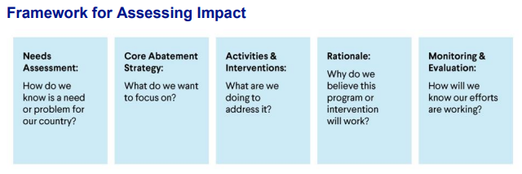
What will your measures of success be? How will you know your efforts are working? ________________________________________________________________________________________________________________________________________________________________________________________________________________________________________________________________________________________________________________________________________________________________________________________________________________________________________________________________
Will vendors be required to capture metrics and assess impact of activities utilizing settlement funds? ________________________________________________________________________________________________________________________________________________________________________________________________________________________________
What type of monitoring or evaluation support does your county need? ________________________________________________________________________________________________________________________________________________________________________________________________________________________________
What information does your county plan to share publicly? ________________________________________________________________________________________________________________________________________________________________________________________________________________________________________________________________________________________________________________________________________________________________________________________________________________________________________________________________
Does your county have a website that will house this information? ________________________________________________________________________________________________________________________________________________________________________________________________________________________________
What additional information will the residents of your county want to see? ________________________________________________________________________________________________________________________________________________________________________________________________________________________________
Consider ways in which your county is prepared to complete an annual voluntary survey.

TOOLS AND RESOURCES

SWOT Analysis
Strengths: What are the strengths of your community in addressing the drug overdose crisis? | Weaknesses: What are the weaknesses associated with your community addressing the drug overdose crisis?
Opportunities: What opportunities does your community have in addressing the drug overdose crisis? | Threats: What threats are present to your community in addressing the drug overdose crisis?

Logic model
Overarching Goal:

LoGic Model

Overarching Goal: What does the county want to achieve? ________________________________________________________________________________________________________________________________________________________________________________________________________________________________________________________________________________________________________________________________________________________________________________________________________________________________________________________________
Assumptions: What are the underlying assumptions associated with this work? Why are the chosen activities and interventions the correct ones? ________________________________________________________________________________________________________________________________________________________________________________________________________________________________________________________________________________________________________________________________________________________________________________________________________________________________________________________________
External Factors: What barriers exist in achieving the goal(s)? What factors assist in achieving the goal(s)? ________________________________________________________________________________________________________________________________________________________________________________________________________________________________________________________________________________________________________________________________________________________________________________________________________________________________________________________________
Inputs: What resources will be needed to meet the goal? ________________________________________________________________________________________________________________________________________________________________________________________________________________________________________________________________________________________________________________________________________________________________________________________________________________________________________________________________
Outputs: Which activities and interventions are to be utilized? ________________________________________________________________________________________________________________________________________________________________________________________________________________________________________________________________________________________________________________________________________________________________________________________________________________________________________________________________
Measures: How will the outputs be measured? ________________________________________________________________________________________________________________________________________________________________________________________________________________________________________________________________________________________________________________________________________________________________________________________________________________________________________________________________
Outcomes: What are the expected short-term and long-term changes? ________________________________________________________________________________________________________________________________________________________________________________________________________________________________________________________________________________________________________________________________________________________________________________________________________________________________________________________________

ACTION PLAN checklist
Step
Develop separate fund for opioid settlement dollars
Steering committee creation (optional)
Stakeholder engagement
Gather stakeholder data and information
Community needs assessment
Multi-sector strategic planning
Community forums with experts
Strategy/activity selection
Spending plan development
Community comment period
Ongoing monitoring and accountability
Ensure equity and inclusion throughout all steps

Steering Committee activities checklist
Step
1 | Create a separate fund for opioid settlement dollars
2 | Determine average annual amount of funding available
3 | Create engagement strategy associated with community stakeholders
4 | Determine process by which strategies/activities will be identified and funded
5 | Determine goals for public-facing information and materials

CURRENT LANDSCAPE checklist
Step
Determine a neutral convener for stakeholder group meetings
Identify stakeholder groups to include, ensure inclusion of those most profoundly impacted
Have current stakeholders determine which stakeholders are missing from the conversation
Identify data, reports, strategic plans, and other information to be shared by stakeholders
Create opportunities for stakeholders to share their expertise
Create process for assessing current community needs and gaps in the substance use space
Create process for prioritizing strategies/activities
Conduct multi-sector strategic planning process

Proposals FOR FUNDING checklist
Step
Create request for proposals (RFP) for departments and organizations to request funding
Share RFP with stakeholders already engaged, additional stakeholders and the general public
Determine which proposals include collaborative with other organizations or institutions
Determine which proposals address immediate needs, gaps and priorities
Determine which proposals use funds to supplement, rather than supplant, existing funds
Award funding, requiring specific metrics be determined to identify impacts of funds
Finalize spending plan

Monitoring & Accountability Checklist
Step
1 | Determine website/platform for public-facing materials and information
2 | Share plans or hold meetings for public comment period and incorporate public comments
3 | Create and share annual reports highlighting the impact of funds

resources
Step
1 | Michigan Association of Counties – https://micounties.org/opioid-settlement-resource-center/
2 | Michigan Opioid Advisory Commission – http://council.legislature.mi.gov/Council/OAC
3 | Michigan Department of Health and Human Services – https://www.michigan.gov/opioids
4 | National Association of Counties – https://www.naco.org/resources/opioid-solutions-center
5 | National Opioid Settlement – https://nationalopioidsettlement.com/
6 | Opioid Settlement Tracker – https://www.opioidsettlementtracker.com/

